Motor Controllers

Reference

<https://www.pololu.com/docs/0J38>

Configuration program

<https://www.pololu.com/file/0J221/jrk-windows-121204.zip>

To control the different motors of the rover (DC Motors), We rely on the Pololu JRK 21v3 which is a motor controller with a serial controller for programming.

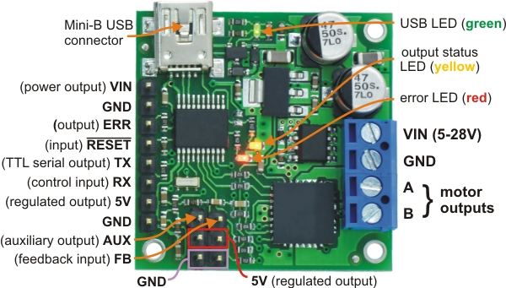

Some of the features of this board:

|  |
| --- |
|  |

* Simple bidirectional control of one DC brush motor.
* 5 V to 28 V operating supply range.
* 3 A maximum continuous current output (5 A peak).
* Four communication or control options:
  + USB interface for direct connection to a PC.
  + Full duplex, TTL-level asynchronous serial interface for direct connection to microcontrollers or other embedded controllers.
  + Hobby radio control (RC) pulse width interface for direct connection to an RC receiver or RC servo controller.
  + 0–5 V analog voltage interface for direct connection to potentiometers and analog joysticks.

Considering the Robot configuration one steering motor and one wheel motor

Two boards can be configured in dual USB mode and stacked together to simplify the wiring (instead of using one USB cable for each board we use one cable for each pair of drivers.

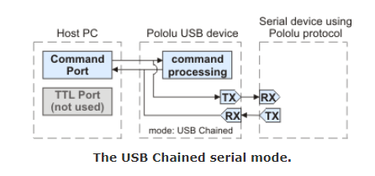

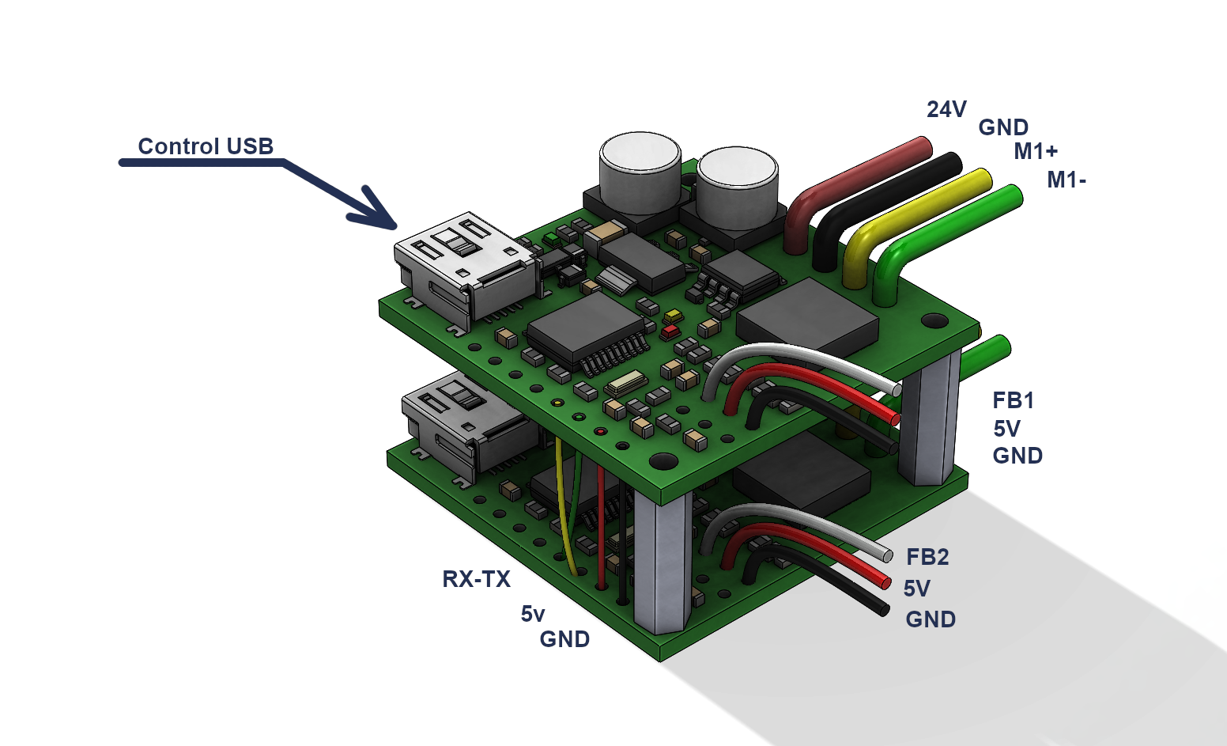

The main driver works in Dual USB Mode in this config the steering Motor

The additional driver works in UART mode with a fixed BAUD rate of 9600bps

Two configuration files are provided as a sample Encoder sensor, potentiometer sensor

**Wheel motor**

For the wheel motor the required sensor (for speed measuring) is an encoder for the control algorithm the measurement is a number of counts per second.

**Steering motor**

To control the steering motor we need an absolute position sensor so this becomes a number related to an angle of the shaft